VAPT PoC Report: SSRF Exploitation
Step1: - Go to product page
→ Intercept request in Burp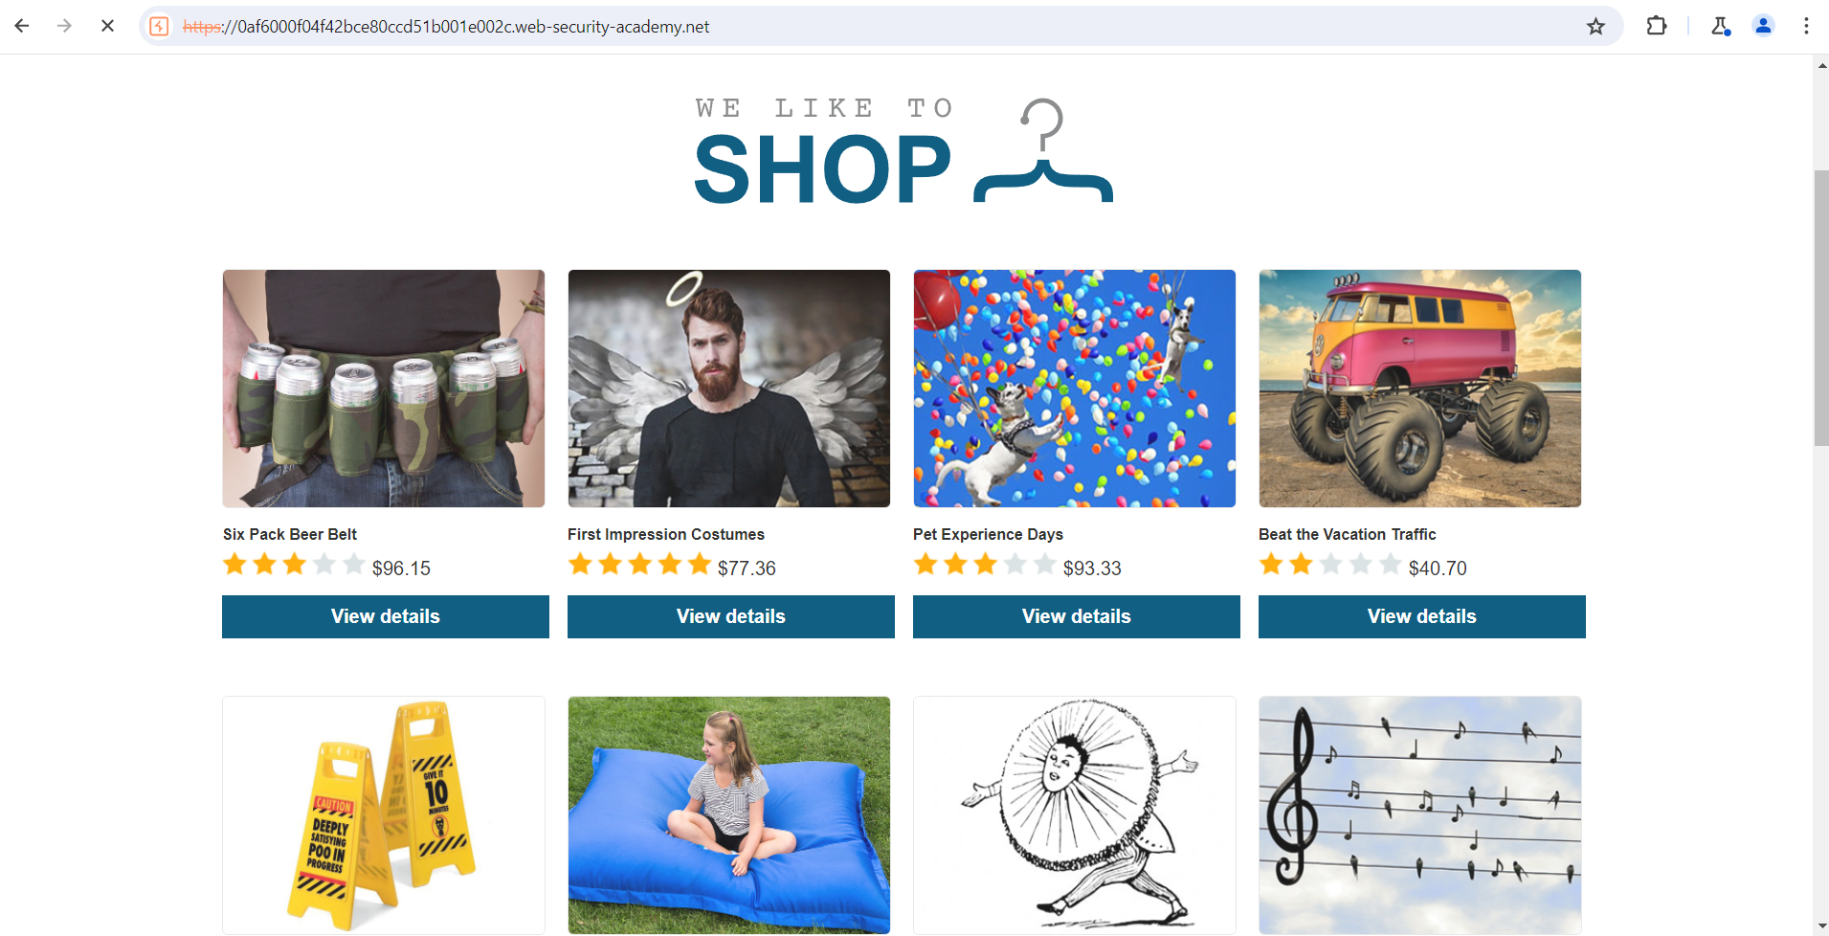

Step 2: - Send request to Repeater, In request, find Referer header
Replace with:
Referer: http://YOUR-COLLABORATOR-ID
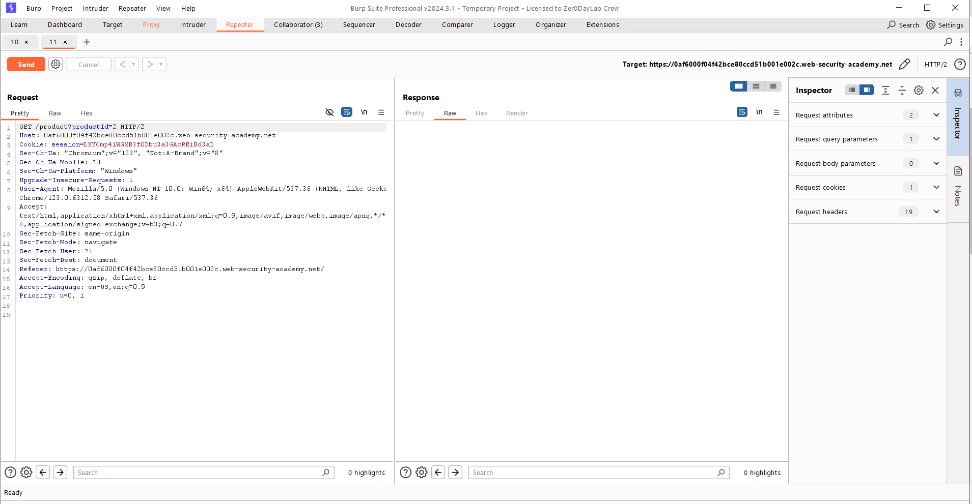
Step 4: - Send request Go to Collaborator tab
Click Poll now
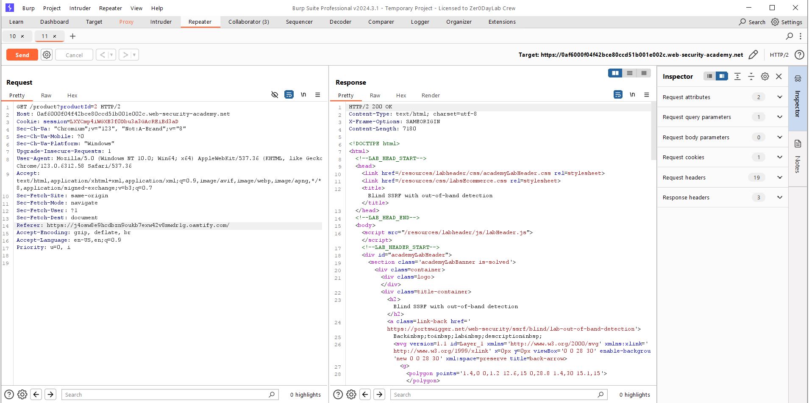

Step 5: - Collaborator tab
Click Poll now Observe interactions
✅ DNS / HTTP requests received

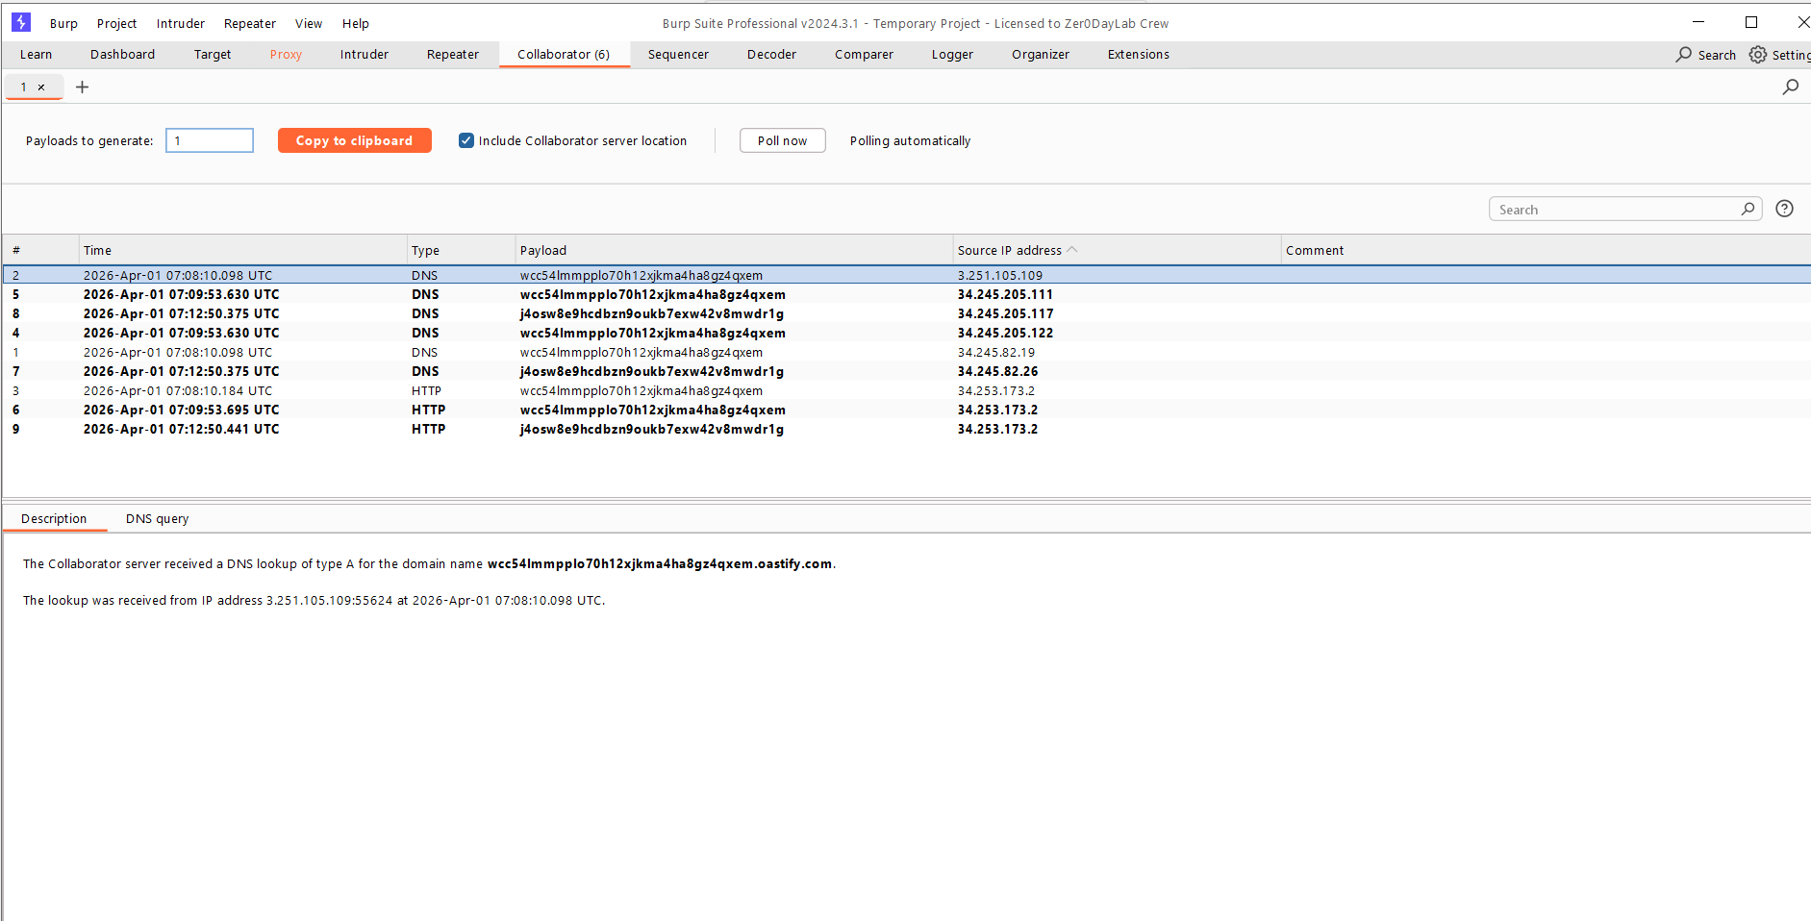
Step 6: - change the refer header request form the capture request and send the lab will solve successfully .